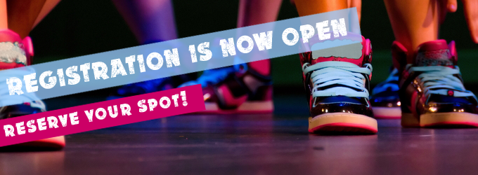
Classes for our 2020-2021 School Year are FILLING UP FAST!
Have you finished your registration? If you are referring another family, do they have any questions to complete their registration?
We want to help you get ready! If you haven't enrolled yet please do so in your Parent Portal before your spots are full. Fall Classes begin the day after Labor Day Tuesday, September 8th!

Studio Calandar 2020-2021

​Classes Sart Tuesday, September 8th

(there's an extra Monday in November so Monday students make up for missing Labor Day)
We Follow School Closures for All Major Holidays - Here are the Holiday Closure Dates Below
- ​Closed November 23-29 for Thanksgiving Holiday
- Closed December 21-January 3 for Christmas/New Year Holiday
- Closed February 15-17 for Mardi Gras Holiday - (3 extra days in March make up for this)
- Closed April 2-9 for Easter Holiday/Spring Break
​Classes for the 2020-2021 Season will end Saturday, May 29th
6th Annual RAVE Revue!
- Annual RAVE Revue 2021 Tech/Performance Dates - June 4th-5th at the Dunham School Theatre
Here is a Reminder of the Class Schedule for 2020-2021

Mondays
Studio A | Studio B
5:00-6:00 Extra Ballet Technique (Ages 9-12) | 5:00-6:00 Primary A Ballet & Tap (Age 5)
6:00-7:30 Level 3 Ballet | 6:00-6:45 Junior/Pre-Teen Company Team Block
 | 6:45-7:30 Level 2 Tap
7:30-8:30 Level 3 Contemporary

Tuesdays
Studio A | Studio B
5:00-5:45 Mini Hip Hop (Ages 7-9) | 5:00-5:45 Level 1 Jazz
5:45-6:30 Musical Theatre I (Ages 7-9) | 5:45-6:45 Level 1 Ballet
6:45-7:45 Level 3 Tap | 6:45-8:00 Level 2 Ballet
7:45-8:45 Level 3 Jazz | 8:00-8:45 Level 2 Contemporary

Wednesdays
Studio A | Studio B
4:45-5:45 Little Movers PK-4 (Age 4) | 5:00-5:45 Secondary Ballet (Ages 7-8)
5:45-6:30 Tertiary Ballet (Ages 8-9) | 5:45-6:45 Secondary Tap & Jazz (Ages 7-8)
6:30-7:45 Tertiary Tap & Jazz (Ages 8-9) | 6:45-7:45 Musical Theatre II (Ages 10 and up)
7:45-9:00 Teen/Senior Company Team Block | 7:45-9:00 Teen/Senior Company Team Block

Thursdays
Studio A | Studio B
4:45-5:30 Little Movers PK-3 (Age 3) | 5:00-5:45 Level 1 Tap
5:30-6:30 Primary B Ballet & Tap (Age 6) | 5:45-6:30 Level 1 Hip Hop
6:30-7:15 Level 2 Hip Hop | 6:30-7:15 Level 1 Contemporary
7:15-8:15 Level 2 Jazz | 7:15-8:15 Pre-Pointe/Pointe (by placement only)
8:15-9:00 Level 3 Hip Hop

Saturdays
Studio A | Studio B
9:15-10:00 Acro/Stretch & Strength II | 9:15-10:00 Acro/Stretch & Strength I
10:00-12:30 Company Team Rehearsals | 10:00-12:30 Company Team Rehearsals

Please CLICK HERE to review our studio policies, dress code, and tuition rates

IN PERSON & VIRTURAL
We will be offering families the opportunity for their dancers to train in person or virtually. Registration will go the same for both, please let us know via e-mail if you would like your dancer to train virtually until further notice. We will be posting live stream links to your parent portals and on the website when classes begin. This will also be beneficial in the event a family has to quarantine at some point, their dancer can Livestream from home.

We miss having y'all register in-person in the studio this year. We know many of you prefer to talk in person when registering. If anyone has any questions please reach out. I'm happy to talk to anyone by e-mail, phone call, or Facebook message on the RAVE Facebook page.

TENT SALE
We will be holding registration day/shoe and attire day alternative this year on Saturday, August 15th, 10 am-1 pm. We will set up a tent out in front of the studio with our shoes and dancewear for sale in addition to our shoe fit testers for anyone to place an order. We can also talk registration in person for anyone who still needs to.

We are so excited for our new season!

Sincerely,
Rachel Vierck
Owner/Director
RAVE Performing Arts Co.
www.raveperformingartsco.com

