Picture Day Info
We will be going forward with our Picture Day at the studio on Saturday, June 6th Reminder to all families, if you do not feel comfortable attending yet, Picture Day is not mandatory
Here are the time slots for each class.
- 9:00 – 9:45 am Little Movers PK-3 and PK-4
- 9:45 – 10:30 am Primary
- 10:30 – 11:30 am Secondary A & B
- 11:30 – 12:30 pm Tertiary
- 12:30 – 1:00 pm Break
- 1:00 – 2:00 pm Level 1
- 2:00 – 2:30 pm Theatre
- 2:30 – 3:30 pm Level 2
- 3:30 – 4:30 pm Level 3
- 4:30 – 5:00 pm Makeup Pictures for anyone who couldn’t come earlier

Picture Day Protocol – 2020 edition
- In accordance with the current statewide Phase 1 re-opening guidelines, we are adjusting our Picture Day protocol this year for the safety of all involved. Please thoroughly read the information below.
- Arrive at the studio with your dancer’s hair and makeup already done and costume on 10 min before your designated time frame.
- When you arrive, check-in with our attendant at the table outside of the studio. When the photographer is ready for your dancer, someone will escort them in to have their picture taken. Be prepared to wait in your vehicle until called on for pictures.
- Everyone entering the building will have their temperature taken upon entry by a forehead scan thermometer and will be required to sanitize their hands. All parents/guardians entering will be required to wear a mask.
- Only one parent/guardian may enter the lobby with the dancer. While the dancer is being photographed, the parent or guardian may finish up paperwork and payment with the photographer’s assistant at the desk. No one will be allowed in the studio space where pictures are being taken other than the photographer, the student, and our teaching staff. Parents awaiting their child to be done can watch the session on the TV screen in the lobby.
- There will be no group pictures this year, only individuals may be taken. Only siblings can be photographed together.

- We will also be limiting costume changes. If your student is in more than one class and has a few costume options, we are limiting costume changes to a max of 3 costumes. Students cannot exceed this amount. For students wishing to take pictures in 2-3 costumes, we will open studio A for quick changes into the next costume. We will only be allowing 2 students and their parent/guardian in Studio A to change at a time, and everyone who enters Studio A must wear a mask. Only female parents/guardians will be allowed to enter the changing area with their dancer. Once one student has finished changing then they are required to leave studio A and wait outside once again until it is time for them to take the next picture.
- Students and parents are not allowed to “hang out” in either Studio space. We want to limit the number of people in the space at any given time
Additional info About Picture Day
- You can wait to purchase the pictures until you see the proofs online. However, If you choose to purchase pictures the day of there is a discount for day-of purchases
- If you can, please come prepared with your order form printed and filled out, it will make the process much easier on the photographers and staff
- Here is the order form below for preview. We have also attached a separate page with only the form on it for print out

Find the Picture Day Form and additional info on the next page

**Order the day photos are taken to get the discount prices below! Please fill out one order form per costume**

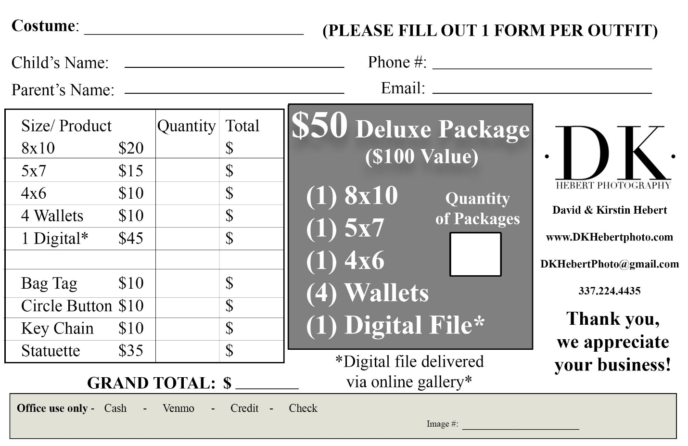

IMPORTANT INFO
**Online ordering will become available approximately 2 weeks after the photos are taken if you choose to wait and order later. However, The Deluxe Discount package is only available the day of due to bulk ordering. Our photographers order prints through a company, they do not make the prints themselves. Therefore, ordering prints later will incur a charge of $5 more per print in addition to shipping costs. **

- When the prints ordered on Picture Day are ready for pick up, we will announce a pickup day at the dance studio for you to pick up your orders.

