Little Movers PK-3 – “Duck Tales”
- Costume is Customized so there is no picture
- Each student has received the following:
- A colored leotard
- White shorts
- A white tutu with gold sequins
- Each student will receive either Thursday at Class or Saturday at Picture Day:
- White gloves with a sequin trim matching their leotard
- White bows – 2 for feet, one for hair
- The Tutu is to be pinned to the dancer’s bottom, not worn around waist, will be demonstrated how to pin it during Parent Watch this week
- Costume must be worn with:
- Flesh colored tan tights
- Black patent mary jane taps
- Hair should be worn in:
- High ponytail, with bow on top
Little Movers PK-4 – “When I’m Older” (Frozen)
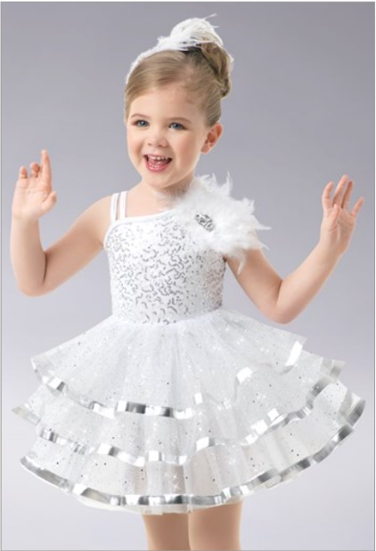 | - Costume Includes:  - Dress with attached leotard  - Hair Piece  - Must be worn with:  - Flesh color tan tights  - Black patent mary jane taps  - Hair should be worn in:  - High Ponytail with hairpiece on right side of ponytail holder  **Pro Tip – to plump up the tutu and flatten the wrinkles, please keep out of bag, hung upside down until worn. Please also either steam the tutu or hang in bathroom upside down while shower is running so steam releases the wrinkles**

Primary A Ballet – Princess Instrumental (from Cinderella)
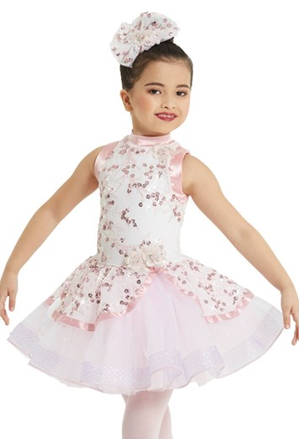 | - Costume Includes:  - Leotard with attached tutu  - Hair Piece  - Must be worn with:  - Pink ballet tights  - Pink ballet slippers  - Hair should be worn in:  - Slick high bun with hair piece on right side of bun (as pictured)  **Pro Tip – to plump up the tutu and flatten the wrinkles, please keep out of bag, hung upside down until worn. Please also either steam the tutu or hang in bathroom upside down while shower is running so steam releases the wrinkles**

Primary A Tap – Lilo & Stitch Hula
- Costume is Customized so there is no picture
- Each student has received the following:
- A coral colored biketard
- A colorful green hula tutu
- A floral headpiece
- A stretchy band with flowers and ribbon (goes around chest at top of biketard)
- We will show parents at parent watch and picture day how costume should be worn for assistance
- Costume must be worn with:
- Flesh colored tan tights
- Black patent mary jane taps
- Hair should be worn in:
- High bun

Primary B Ballet - “A Whole New World” (Aladdin)
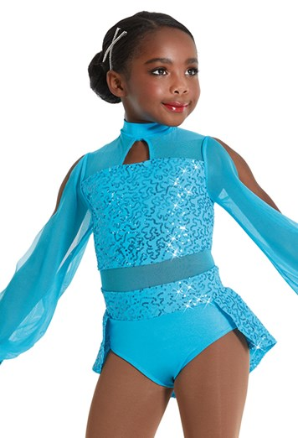 | - Costume Includes:  - Blue leotard  - Hair Piece – Princess Jasmine Headband  - Must be worn with:  - Pink ballet tights  - Pink ballet slippers  - Hair should be worn in:  - Slick mid/low ballet bun with headband

Primary B Tap - “101 Dalmations”
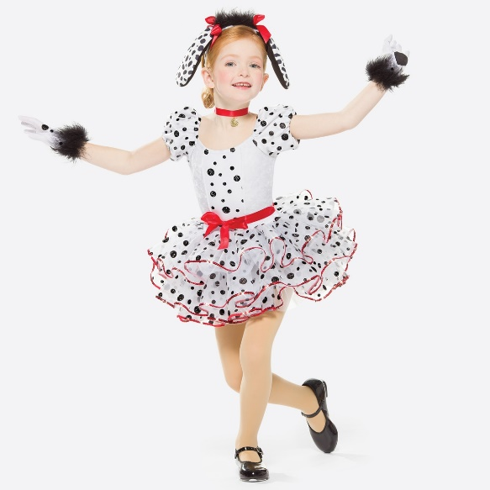 | - Costume Includes:  - Leotard with attached skirt and tail  - Gloves  - Puppy ear headband  - Red neck ribbon/collar (gold piece attached)  - Plain red ribbon to be tied around waist in a bow (as seen in picture)  - Must be worn with:  - Flesh colored tan tights  - Black patent mary jane taps  - Hair should be worn in:  - Slick mid/low ballet bun with headband

Secondary Ballet – “Part of Your World” (Little Mermaid)
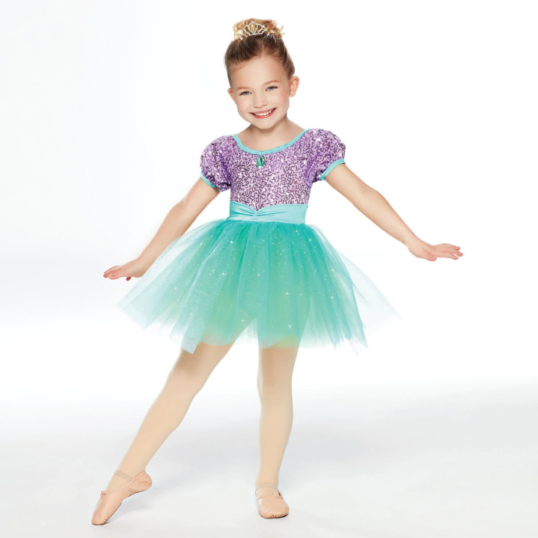 | - Costume Includes:  - Leotard with attached skirt  - Hair Piece – little tiara  - Must be worn with:  - Pink ballet tights  - Pink ballet slippers  - Hair should be worn in:  - Slick high bun with tiara at top  **Pro Tip – to plump up the tutu and flatten the wrinkles, please keep out of bag, hung upside down until worn. Please also either steam the tutu or hang in bathroom upside down while shower is running so steam releases the wrinkles**

Secondary Jazz – “Shake Your Tailfeather” (Chicken Little)
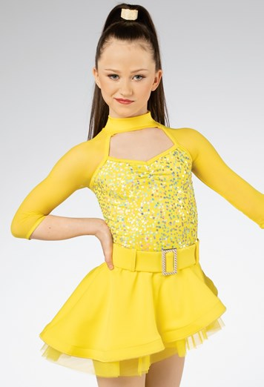 | - Costume Includes:  - Leotard with attached skirt  - Hair Piece – rhinestone ponyholder  - Must be worn with:  - Flesh colored tan tights  - Tan jazz shoes  - Hair should be worn in:  - Slick high ponytail with hair piece (as pictured)

Secondary Tap – “Hoedown Throwdown” (Hannah Montana)
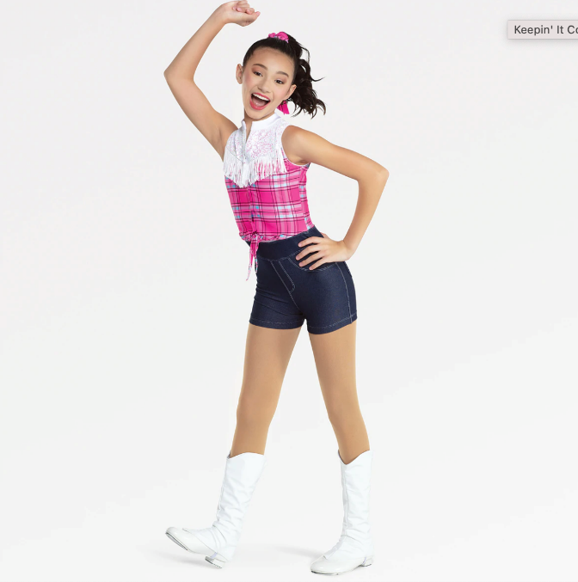 | - Costume Includes:  - biketard  - Hair Piece  - Boot covers  - Must be worn with:  - Flesh colored tan tights  - Tan buckle tap shoes  - Hair should be worn in:  - Slick high ponytail with hairpiece (as pictured)

Mini Hip Hop – “Push it to the Limit” – Disney Channel Movie Jump In
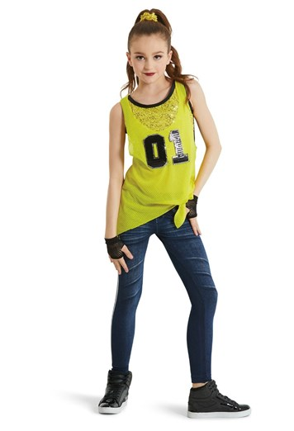 | - Costume Includes:  - Two piece costume includes jersey with attached bra top and jeggings  - Athletic jersey mesh tank is tied at the waist  - Sequin scrunchie  - Mesh gloves  - Must be worn with:  - Any black and white sneakers you have, may be given some before Revue  - Hair should be worn in:  - Slick high ponytail with scrunchie

Tertiary Ballet – “Reflection” (Mulan)
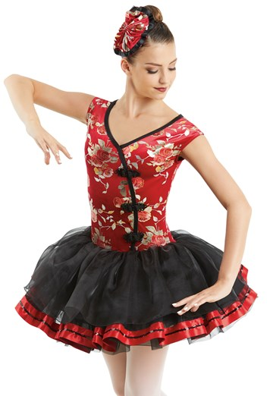 | - Costume Includes:  - Leotard with attached tutu  - hairpiece  - Must be worn with:  - Pink ballet tights  - Pink ballet shoes  - Hair should be worn in:  - Slick high bun with hairpiece on right side (as pictured)  **Special note (some of the tops are a little big on the dancers, as they were made to have room in the chest. Please try on your dancer and pen with safety pins for fitting if needed)  **Pro Tip – to plump up the tutu and flatten the wrinkles, please keep out of bag, hung upside down until worn. Please also either steam the tutu or hang in bathroom upside down while shower is running so steam releases the wrinkles**

Tertiary Tap – “When We’re Human” (Princess and the Frog)
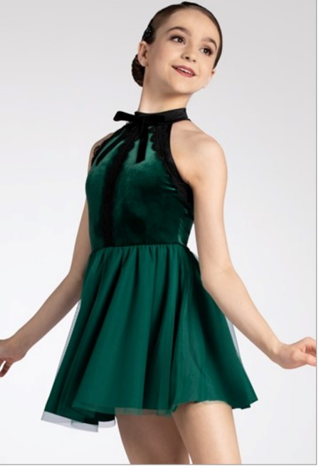 | - Costume Includes:  - Dress with attached leotard  - Must be worn with:  - Tan flesh tone tights  - Tan lace up rhythm taps  - Hair should be worn in:  - Slick high ponytail with applique on right side of hair (seep picture for applique)

Tertiary Jazz – “Magic Happens” (Disneyland Parade)
- Costume Includes:
- Dress with attached trunks

- Must be worn with:
- Flesh colored tan tights
- Tan jazz shoes

- Hair should be worn in:
- Slick high ponytail

Musical Theatre I – Beauty and the Beast Suite
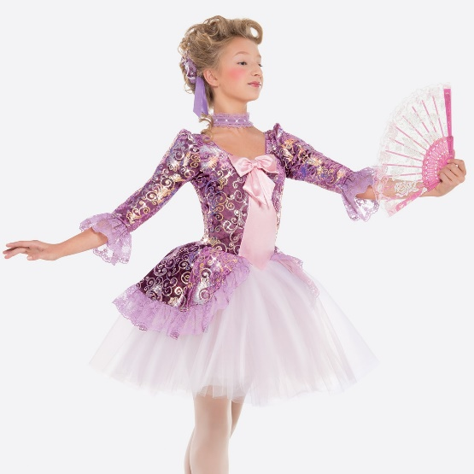 | - Costume Includes:  - Leotard with attached skirt  - headpiece w/bobby pins  - Choker  - lace fan  - Must be worn with:  - Tan flesh colored tights  - Tan jazz shoes  - Hair should be worn in:  - Slick mid to low bun  - Student playing Lumiere is in gold dress with attached trunks, see Miss Rachel for details or accessories  **Pro Tip – to plump up the skirt and flatten the wrinkles, please keep out of bag, hung upside down until worn. Please also either steam the skirt or hang in bathroom upside down while shower is running so steam releases the wrinkles**

Level 1 Ballet – Circle of Life Instrumental (Lion King)
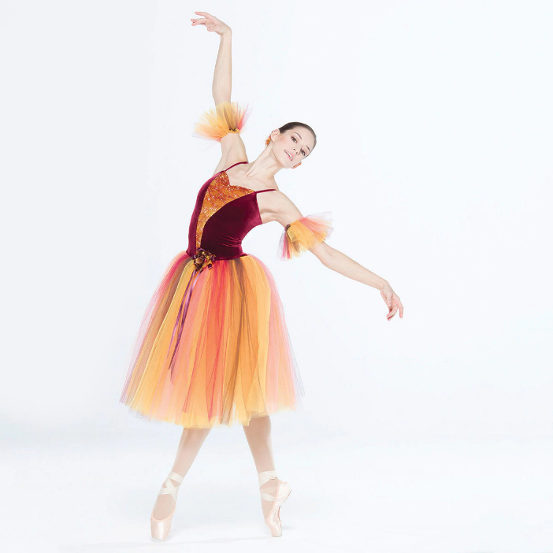 | - Costume Includes:  - Leotard with attached tutu  - Bun topper  - Arm ruffles  - Must be worn with:  - Pink ballet tights  - Pink ballet shoes  - Hair should be worn in:  - Slick mid to low ballet bun with hairpiece on right side of bun  **Pro Tip – to plump up the tutu and flatten the wrinkles, please keep out of bag, hung upside down until worn. Please also either steam the tutu or hang in bathroom upside down while shower is running so steam releases the wrinkles**

Level 1 Tap – “I’ll Make a Man Out of You” (Mulan)
- Costume is Customized so there is no picture
- Making a final decision this week between 3 costumes
- Will send out info once decided

Level 1 Jazz – “I2I” (A Goofy Movie)
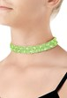 | - Customized Costume so no picture of full look put together (not pictured in collage, scrunchie)  - Costume Includes:  - Black leotard  - Green and black skirt  - Green choker  - Green scrunchie (students receiving on Tuesday before Picture Day)  - Must be worn with:  - Tan flesh tone tights  - Tan jazz shoes  - Hair should be worn in:  - Slick mid-low bun with scrunchie around bun

Level 1 Contemporary – “Colors of the Wind” (Pocahontas)
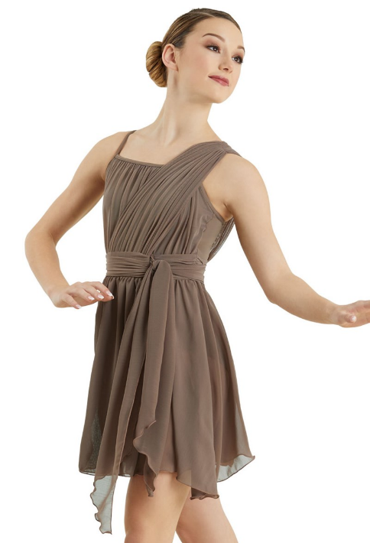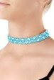 | - Costume Includes:  - Dress with attached leotard  - Aqua blue choker  - Must be worn with:  - No tights  - Barefoot or foot paws for shoes  - Hair should be worn in:  - Slick mid-low bun  **Special note the shoulder piece can get twisted and a bit confusing to put on, please check that the shoulder piece is on the left shoulder, with the tie in the front, as pictured

Level 1 Hip Hop – Camp Rock
- Costume Includes:
- Red jumpsuit
- Black baseball cap
- Plaid shirt (not pictured)

- Must be worn with:
- Plaid shirt tied around waist
- A black sports bra underneath
- Black & white sneakers (will either wear your own, or will be given some before the Revue, will notify if we can supply them)

- Hair should be worn in:
- Slick mid-low pony with hat on tip

Level 2 Ballet – UP!
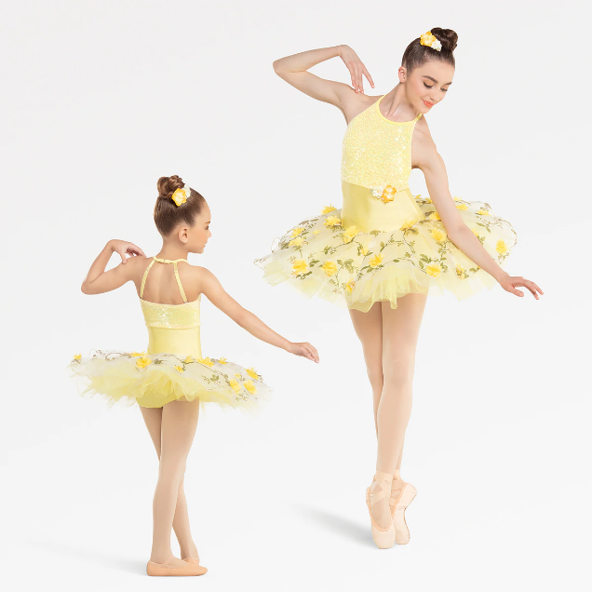 | - Costume Includes:  - Leotard with attached tutu  - Hairpiece with bobby pins  - Must be worn with:  - Pink ballet tights  - Pink ballet shoes  - Hair should be worn in:  - Slick mid-low bun with hair piece on right side  **Pro Tip – to flatten the wrinkles, please keep out of bag, hung upside down until worn. Please also either steam the tutu or hang in bathroom upside down while shower is running so steam releases the wrinkles**

Level 2 Tap – Monsters Inc.
- Costume Includes:
- Leotard with attached skirt
- Headpiece (won’t wear headpiece)
- Each student was given a different color costume

- Must be worn with:
- Tan flesh colored tights
- Black lace up rhythm taps
- Monsters Inc. Workhat (will be passed out at show)

- Hair should be worn in:
- Slick mid-low bun

Level 2 Jazz – “Friend Like Me” (Aladdin)
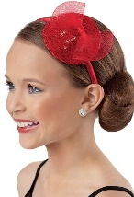 | - Costume Includes:  - Blue dress with attached leotard  - Red headband  - Gold Cuffs (not pictured) – will issue these this week before picture day  - Must be worn with:  - Tan flesh tone tights  - Tan jazz shoes  - Hair should be worn in:  - Slick mid-low bun with hat on headband on the right side, pin the headband to hair with bobby pins

Level 2 Contemporary – Oogie Boogie Song Instrumental (Nightmare Before Christmas)
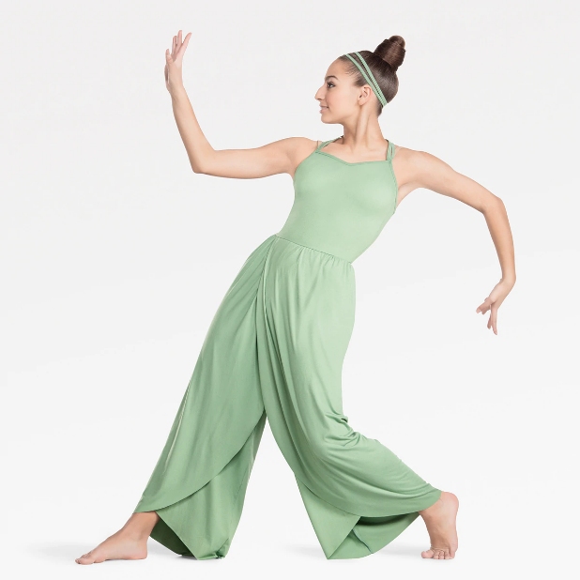 | - Costume Includes:  - Jumpsuit  - headband  - Must be worn with:  - Barefoot or with dance paws on feet  - Hair should be worn in:  - Mid-low bun with headband

Level 2 Hip Hop - TRON
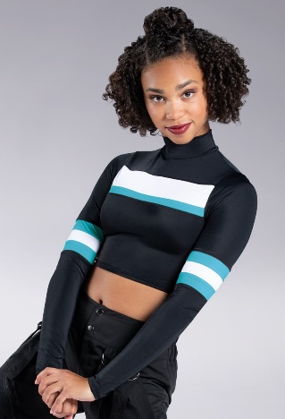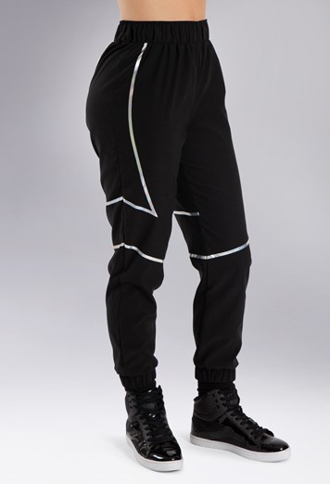 | - Costume Includes:  - Crop top  - Jogger pants  - Must be worn with:  - Black and white sneakers (your own unless we are able to supply them. Will notify soon on this)  - Hair should be worn in:  - Mid-low pony

Musical Theatre II – Beauty and the Beast Suite
- Students received this base look on the left side, in one of the 3 colors shown

- In addition students will also layer black cropped leggings on top of biketard (will be receiving in class this week) and will have additional accessories per song in their production (studio will keep and pass out at show)

- Must be worn with:
- Tan jazz shoes

- Hair should be worn in:
- Low ponytail

Level 3 Ballet – Cruella DeVille
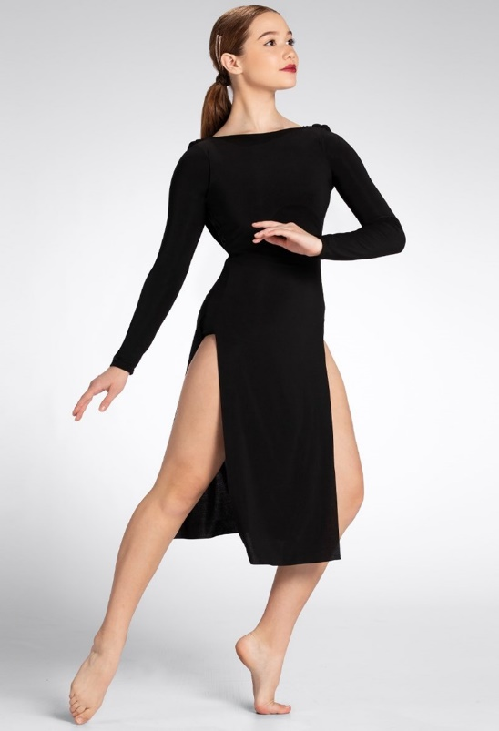 | - Costume Includes:  - Black dress with attached leotard  - Must be worn with:  - Tan flesh tone tights  - Pink ballet shoes or pointe shoes  - Hair should be worn in:  - Slick mid-low bun  Prop – Students have a black and white boa that the studio will keep and hand out at show

Level 3 Pointe – Sleeping Beauty
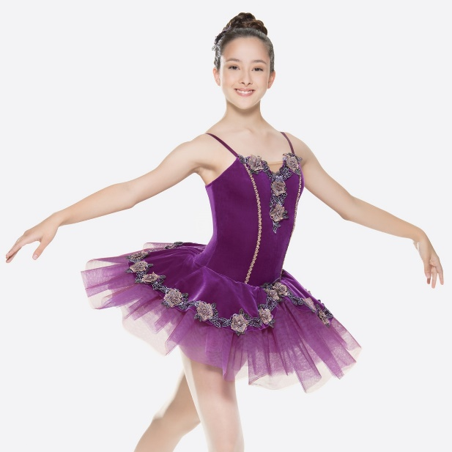 | - Costume Includes:  - Leotard with attached tutu  - Hairpiece with bobby pins  - Must be worn with:  - Pink ballet tights  - Pink ballet shoes or pointe shoes  - Hair should be worn in:  - Slick mid-low bun with hair piece on right side  **Pro Tip – to flatten the wrinkles, please keep out of bag, hung upside down until worn. Please also either steam the tutu or hang in bathroom upside down while shower is running so steam releases the wrinkles**

Level 3 Tap - Ratatouille
- Costume is Customized so there is no picture
- Each student has received the following:
- A striped 3 quarter length tee
- A black skirt with attached trunks
- A black French beret
- Costume must be worn with:
- Flesh colored tan tights
- Black lace up rhythm taps
- Hair should be worn in:
- Mid-low pony, beret leaning to right side

Level 3 Jazz – The Incredibles
- Costume Includes:
- Red dress with attached leo inside
- Black super hero mask

- Must be worn with:
- Tan flesh colored tights
- Tan jazz shoes

- Hair should be worn in:
- Slick mid-low bun

Level 3 Contemporary – “God Help the Outcasts” (Hunchback of Notre Dame)
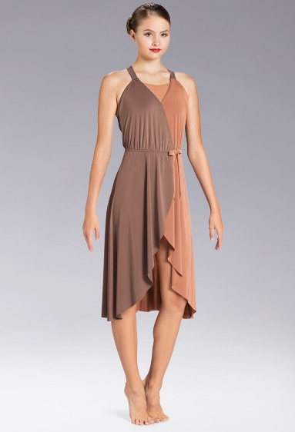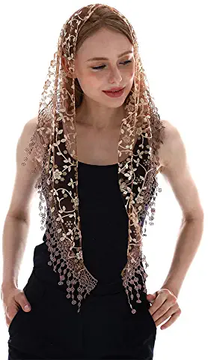 | - Costume Includes:  - Dress with attached leo  - Must be worn with:  - pirouettes  - Hair should be worn in:  - Slick mid-low bun  Prop – church veil (will be kept at studio for practice)

Level 3 Hip Hop – Black Panther
- Costume Includes:
- Black cut out hoodie
- Black moto jeggings

- Must be worn with:
- Black sports bra
- Black and white sneakers (your own unless we are able to supply them, will let you know if we can supply them)

- Hair should be worn in:
- Mid-low pony

